國立中央大學學生論文比對結果報告書

The Report of National Central University Student Thesis Similarity Check

姓名  Name |  | 系所  Department/Institute |  |  | 學號  Student ID
學年度  Academic Year |  | 身份  Program | □碩士班 Master's Program  □碩士在職專班 In-Service Master's Program  □博士班 Doctoral Program
提交版本  Version | □初稿：申請學位考試 Draft: The version submitted for the degree examination  □完稿：畢業離校時繳交系所及上傳本校圖書館之版本 Final Version: The version submitted to the department/institute and uploaded to the NCU Library upon graduation clearance
論文題目
Thesis Title
論文公開選項  Thesis Release  Option | 口試通過後， □立即公開 □申請延後公開。  After passing the oral defense: □Release immediately □ Apply for delayed release
檢測軟體
Detection Software
論文形式  Thesis Format | □傳統論文 Monograph Thesis  □篇章集結式彙編論文 Compilation-based Thesis by Publication  □整合式彙編論文 Integrated Thesis by Publication
檢測日期
Date of Detection
篩選條件
Filter Criteria
相似度比對截圖
Similarity Comparison | 請務必依照說明之範本截圖  Please ensure that you upload a screenshot based on the specified template.
Screenshot
檢附文件 Documents Required | 論文相似度比對報告電子回條 (須包含論文封面、作者姓名、檔案名稱、檔案大小、總頁數、上傳日期)  The Digital Receipt or Similarity Report of the Submitted Thesis (Should contain thesis  cover page, author, file name, file size, page count, and submission date)
系所規定標準值 Standard Threshold Specified by  Department/Institute |  |  | 相似度指數  Similarity Index
指導教授簽章  Thesis Advisor's  Signature or Seal |  |  | 日期  Date
學生簽章  Student's Signature or Seal |  |  | 日期  Date
相關條文  Relevant Regulation | 依本校「博士班、碩士班研究生學位考試細則」第五條第二項及第十二條第一項規定辦理  National Central University Regulations on Degree Examinations for Postgraduate Students Article 5, Paragraph 2 and
 | Article 12, Paragraph 1

1150506

國立中央大學論文比對報告書填寫說明

Instructions for Completing the Report of NCU Student Thesis Similarity Check

一、 申請學位考試備審文件排列順序 Order of Documents for Degree Examination Application:
- 指導教授推薦函【已簽署】Thesis Advisor’s Recommendation Letter (signed by your thesis advisor);
- 學生論文比對結果報告書 Report of National Central University Student Thesis Similarity Check
- 論文相似度比對報告電子回條 Digital Receipt or Similarity Report of the Submitted Thesis
- 系所規定審核文件 Other documents required by your department/institute
- 論文提要 Thesis abstract
- 論文初稿 Thesis draft

二、 檔案名稱一致性 File Name Consistency:
論文比對結果報告書中的相似度比對截圖，檔案名稱請寫「學號」。
相似度比對截圖的檔案名稱，須與電子回條「Submission title」或「File name」的檔案名稱相同。
The file name of the screenshot of the Report of NCU Student Thesis Similarity Check must be your student ID. The file name of the screenshot must match that of the "Submission title" or "File name" on the electronic receipt.

三、 截圖清晰度 Screenshot Clarity:
相似度比對截圖請保持清晰可辨，避免提交的圖片檔案過小，放大後無法判讀，請特別留意截圖品質。相似度比對截圖路徑如下圖，請務必依照論文比對結果報告書範本截圖。
Ensure the screenshot of the Report of NCU Student Thesis Similarity Check is clear and legible. Avoid submitting low-resolution images that become unreadable when enlarged. Pay close attention to image quality. The screenshot area is shown in the figure below. Please ensure that the screenshot strictly follows the format of the Report's template.

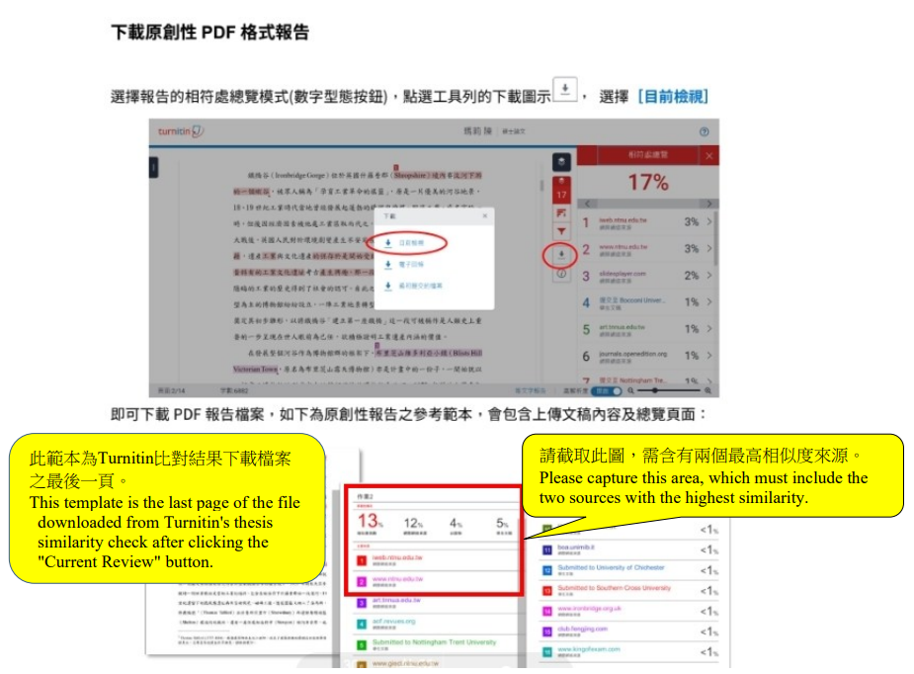

四、 論文比對結果報告書每個欄位皆必填，若沒有篩選條件請寫「無」。
Completion of All Fields:
All fields in the Report of NCU Student Thesis Similarity Check must be completed. If no filtering criteria were applied, fill in “NA.”

五、 「學生論文比對結果報告書」請務必使用註冊組網站最新表格，並依照註冊組規定之範本截圖，不符合者將退件。

Use of Latest Template:
The “Report of NCU Student Thesis Similarity Check” must be completed using the latest template available on the Registration Division website.
Screenshots must follow the format specified by the Register Division. Submissions that do not comply with the format will be returned.

國立中央大學學生論文比對結果報告書

The Report of National Central University Student Thesis Similarity Check

姓名  Name |  | 系所  Department/Institute |  |  | 學號  Student ID
學年度  Academic Year |  | 身份  Program | □碩士班 Master's Program  □碩士在職專班 In-Service Master's Program  □博士班 Doctoral Program
提交版本  Version | □初稿：申請學位考試 Draft: The version submitted for the degree examination  □完稿：畢業離校時繳交系所及上傳本校圖書館之版本 Final Version: The version submitted to the department/institute and uploaded to the NCU Library upon graduation clearance
論文題目
Thesis Title
論文公開選項  Thesis Release  Option | 口試通過後， □立即公開 □申請延後公開。  After passing the oral defense: □Release immediately □ Apply for delayed release
檢測軟體
Detection Software
論文形式  Thesis Format | □傳統論文 Monograph Thesis  □篇章集結式彙編論文 Compilation-based Thesis by Publication  □整合式彙編論文 Integrated Thesis by Publication
檢測日期
Date of Detection
篩選條件
Filter Criteria
相似度比對截圖 | 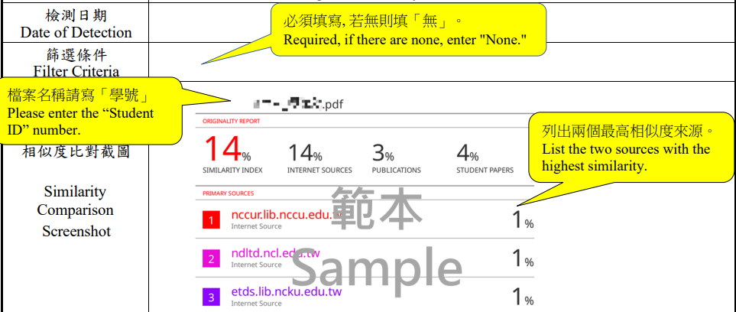
Similarity Comparison
Screenshot
檢附文件 Documents Required | 論文相似度比對報告電子回條 (須包含論文封面、作者姓名、檔案名稱、檔案大小、總頁數、上傳日期)  The Digital Receipt or Similarity Report of the Submitted Thesis (Should contain thesis  cover page, author, file name, file size, page count, and submission date)
系所規定標準值 Standard Threshold Specified by  Department/Institute |  |  | 相似度指數  Similarity Index
指導教授簽章  Thesis Advisor's  Signature or Seal |  |  | 日期  Date
學生簽章  Student's Signature or Seal |  |  | 日期  Date
相關條文  Relevant Regulation | 依本校「博士班、碩士班研究生學位考試細則」第五條第二項及第十二條第一項規定辦理  National Central University Regulations on Degree Examinations for Postgraduate Students Article 5, Paragraph 2 and
 | Article 12, Paragraph 1



